Mohamed Ali
Youm7 Media Group for Journalism & Digital Publishing
YOUM7

Table of Contents
Document Release History 3
Part 1: Industry, Organization, and Business Challenge Selection 4
1.1 Industry and Organizational Context 4
1.2 Business Challenge Definition 4
1.3 Evidence and Supporting Data 4
1.4 Strategic Significance of the Challenge 4
Part 2: Business Problem Diagnosis, Root Cause Analysis, and Current-State Workflow 5
2.1 Root Cause Analysis (5 Whys Framework) 5
2.2 Stakeholder Impact Analysis 6
2.3 Current-State Process Map and Inefficiencies 6
Part 3: Exploration and Evaluation of the Three Technology Options 7
Part 4: Technology Solutions Evaluation and Trade-off Matrix 8
Part 5: Proposed Post-Consolidation Operating Structure: 9
Part 6: Conceptual Technical Architecture 10
Part 7: Financial Feasibility Study & Investment Appraisal 12
7.1 Estimated 3-Year Total Cost of Ownership (TCO) 12
7.2 Tangible Financial Benefits & Revenue Impact 13
7.3 Investment Metrics 13
Part 8: Phased Implementation Roadmap & Rollout Strategy 14
Part 9: Risk Management, Hallucination Governance, and Ethical AI Framework 15
Part 10: Table: Strategic & Operational KPI Dashboard Matrix 16

Executive Consulting Report: Digital Transformation Strategy for News Publishing Lifecycle and Smart Editorial Workflow
Target Organization: Youm7 Media Group for Journalism & Digital Publishing
Target Audience: The Board of Directors and Executive Editorial Leadership
Consulting Engagement: Developing the Editorial, Fact-Checking, SEO Optimization, and Automated Publishing Ecosystem via Interactive AI (AI-Powered Smart Newsroom)
Strategic Objective: Remove the bottlenecks in digital news production and verification. The targets are a Time-to-Publish under 40 minutes instead of 180, a 45% gain in SEO compliance quality, and 90% fewer editorial errors, delivered with a positive return on investment, protected intellectual property, and journalistic credibility intact.

Document Release History

# | Version | Issue Date | Author | Comments
1 | v 1.00 | 1/09/2026 | Mohamed Ali | Initial publication

Reviewers

# | Name | Role
1 | xxx | Product Management Director

Part 1: Industry, Organization, and Business Challenge Selection

Industry and Organizational Context
Industry: Digital journalism and news media publishing. Organization: Youm7 Media Group, the leading digital news website in Egypt and the Middle East and North Africa. Its newsroom works around the clock and publishes over 600 news articles, multimedia reports, and live updates every day. Production is centralized across several desks staffed by field correspondents, section editors, language checkers, and SEO specialists.

Business Challenge Definition
The problem is the process itself. Editors spend hours polishing sentences and retrofitting SEO while the news moves on. By the time an article goes live it is already dated, it still carries mistakes, and it has lost its position in search results. Youm7 misses the chance to publish first, and the advertising revenue that depends on that traffic drains away.

Evidence and Supporting Data
- Publishing Lead Time Latency: Manual review takes 120 to 210 minutes for in-depth analyses and investigative pieces, averaging 180 minutes. Breaking news verification runs past 35 to 45 minutes, so Youm7 loses the readers who arrive in a story's first minutes.
- SEO Performance Gap: About 42% of published articles fail to rank on Google Search and Google Discover because rushed manual editing leaves out structured metadata, internal links, and semantic tags.
- Post-Publication Error Rate: More than 18% of published stories need a later correction for factual or syntax errors. Each correction costs the newsroom credibility.
- Supporting Industry Data:
Google Algorithmic Penalty & Search Volatility: Similarweb telemetry and Google Search Central benchmarks show that breaking news delayed by more than 10 to 15 minutes loses up to 65% of its immediate organic click-through traffic to aggregators.
Newsroom Capacity Drain: Research by WAN-IFRA indicates that manual proofreading and metadata tagging take up more than 60% of senior editors' working time, which is time not spent on investigative reporting.
Verification & Trust Exposure: The Reuters Institute Digital News Report notes that high-volume digital publishers carry reputational and brand safety risk when they scale production without automated verification checks.

1.4 Strategic Significance of the Challenge
Attention Economy & First-to-Market Window: In fast-moving digital news, a delayed publication loses dwell time and page views.
Programmatic Ad Monetization: Digital ad yields depend on organic search position and on-page engagement.
Competitive AI Disruption: Reuters, Bloomberg, and The Washington Post already run AI-augmented editorial workflows. Holding Youm7's position in the market means moving to a comparable AI-augmented editorial platform.

Part 2: Business Problem Diagnosis, Root Cause Analysis, and Current-State Workflow

Root Cause Analysis (5 Whys Framework)

Category | Root Causes | Financial Impact
Process | Writer  Desk Editor  Copyeditor  Section Head  CMS Publishing Operator | Backlogs in the article queue
Technology | Editors work in standalone word processors that connect to neither the Content Management System (CMS) nor the historical archive. | Time lost to manual information retrieval
Data | No automated semantic linking between new articles, the archive, and real-time audience analytics. | Duplicated stories and weak internal linking
People / Human Capital | Senior editors spend their hours on routine copyediting, grammar fixes, and manual headline formatting. | Editorial burnout and falling quality

Stakeholder Impact Analysis
- Reporters and Field Correspondents:
Their stories publish late, and they cannot see what was changed in their drafts.
- Desk Editors and Copyeditors:
They review hundreds of articles by hand under shift deadlines.
- Digital Marketing and SEO Leadership:
They cannot enforce search engine requirements consistently across a manual workflow.
- Advertisers and the Board of Directors:
They lose revenue as organic impressions and page views fall.

Current-State Process Map and Inefficiencies
- Legacy Linear Pipeline:
- Draft written in MS Word
- Dispatched via email/messaging
- Manually opened and copyedited by desk editor
- Forwarded to linguistic proofreader
- Escalated to Section head
- Manually copied and pasted into CMS dashboard with manual tag/image population
- Published.
- Bottlenecks and Process Waste:
Versions scatter across disconnected files, editors cross-reference the archive for names and dates by hand, nothing checks for plagiarism automatically, and each piece takes more than two hours to publish.

Part 3: Exploration and Evaluation of the Three Technology Options

Criteria | Digitize | Digitalization | Digital Transformation
Technology Mechanism | Automates the review and approval cycle as it stands | Automates the cycle, upgrades the servers, and adds off-the-shelf apps (MS Word, Grammarly) or third-party integrations | Automates the cycle and integrates an AI model that reviews the draft and recommends improvements
User Experience | Speeds up the handover of drafts between editorial staff but gives no help with writing or content generation. | Flags common spelling errors, with no understanding of news context and no fact checking | Writes headlines, summarizes paragraphs, refines text in context, checks facts, and publishes to the web in one click, all in real time
Expected Business Value | Cuts draft handover time by 25%. The whole review burden stays with the editors. | Cuts typographical errors by 30% and draft transition time by 35%. | Cuts publishing lead time by 65%, doubles SEO efficiency, and raises editorial productivity by more than 50%.
Technical Requirements | Development of a new software platform and comprehensive training on workflow management. | Development of a new software platform, Low-cost software subscriptions, installation of browser extensions, and comprehensive training on workflow management. | Secure hosting infrastructure, domain-adapted LLMs (fine-tuned for journalism), and integration with the publishing engine
Limitations and Drawbacks | Costs capital without fixing the main bottleneck, which is slow manual reading and tiring editorial review. | No awareness of news context, a high volume of false-positive alerts, and no automated SEO tagging or fact checking. | Needs strict governance to prevent AI hallucinations, plus an onboarding and calibration period for editorial staff.

Part 4: Technology Solutions Evaluation and Trade-off Matrix

- Justification for Evaluation Criteria & Weight Adjustments:
"The initial evaluation framework gave 15% to both Strategic Fit and Business Value. We changed the weights to 10% across ten criteria so we could add one more: Automated SEO & Semantic Tagging (10%).
In digital journalism, search visibility and how fast a page ranks on engines like Google determine audience reach and advertising revenue. Because the core problem is manual SEO delay and error, each option had to be judged on how well it automates metadata, internal linking, and keyword optimization.
Spreading the weights evenly, 10% per criterion to a total of 100%, gives SEO automation its own weight without pushing strategic and operational viability out of the final decision."
Evaluation Criteria | Weight | Automation  (As is) | Rule-based  Grammar | AI-Augmented Platform
Strategic Fit | 10 % | 0.50 | 0.70 | 0.90
Business Value | 10 % | 0.50 | 0.70 | 0.90
Operational Impact | 10 % | 0.30 | 0.50 | 0.90
Automated SEO | 10 % | 0.20 | 0.40 | 0.90
Technical Feasibility | 10 % | 0.80 | 0.70 | 0.60
Data Readiness | 10 % | 0.80 | 0.70 | 0.60
Implementation Complexity | 10 % | 0.80 | 0.70 | 0.60
Cost / Investment | 10 % | 0.80 | 0.70 | 0.60
Risk & Ethics | 10 % | 0.60 | 0.70 | 0.90
Scalability | 10 % | 0.50 | 0.70 | 0.90
Total Weighted Score | 100 % | 0.58 | 0.65 | 0.78
- Evaluation Summary:
Option 3, the AI-Augmented Editorial Platform, scores highest at 78%. It is the only option that moves publishing lead time, SEO benchmarks, and digital traffic revenue together.

- Table: Strategic Evaluation and Cost-Benefit Trade-Off of AI Model Sourcing Approaches
Sourcing Strategy | Implementation Approach | Cost Structure | Recommendations
SaaS / API-Based | Direct integration via proprietary vendor APIs (e.g., OpenAI, Anthropic) | Recurring per-token pricing rises steeply with daily publishing volume | Not economically sustainable for high-volume, long-term editorial operations.
LLM Built from Scratch | Full in-house engineering, pre-training foundation models on raw bilingual datasets from scratch. | Multimillion-dollar GPU clusters, heavy energy demand, and AI research staff who are hard to hire. | Not feasible, and too costly, for domain-specific publishing automation.
Open-Source Fine-Tuning | Downloading high-performance open-weight bilingual foundation models (GitHub / Hugging Face) | One-time fine-tuning and setup, then fixed and predictable cloud hosting costs with no third-party token fees. | Recommended. Best ROI and lowest TCO of the three.
- Cloud Infrastructure Strategy & Hosting Model
The solution uses a Platform as a Service (PaaS) model rather than SaaS or raw IaaS. Managed cloud application environments and serverless GPU model-serving endpoints (Azure AI or AWS SageMaker) let the organization keep full control of its source code, fine-tuned model weights, and editorial datasets, without the operational overhead of running bare-metal IaaS infrastructure.

Part 5: Proposed Post-Consolidation Operating Structure:
- Field Reporter / Writer (User Task): Enters raw news data, source documents, and the first draft into the interactive editorial workspace.
- AI-Augmented Engine (System Task): Reads the draft in real time and returns proofreading notes, RAG-backed fact verification, internal archive links, and SEO metadata suggestions.
- Unified Content / Desk Editor (User Task): Edits the story and accepts or rejects each AI suggestion with a single click before submitting the finished package.
- Section Head / Editor-in-Chief (User Task):
- Step A: Strategic Sign-off (Approve): Checks the article against editorial policy, legal requirements, and strategic direction, then grants formal approval.
- Step B: Multi-Channel Dispatch (Publish): Selects the target channels and publishes to the production CMS immediately or on a schedule.

Part 6: Conceptual Technical Architecture
- Presentation Layer:
- Interactive Editorial UI / Rich Text Editor: Shows AI recommendations in a contextual side panel as the writer types, with single-click accept and reject controls.
- Orchestration & Business Logic Layer:
- Workflow & State Machine Engine: Manages editorial review pipelines, role-based access control (RBAC), and multi-stage approval states.
- API Gateway & Task Dispatcher: Routes incoming drafting requests, handles asynchronous jobs, and secures the interfaces to external systems.
- AI & RAG Engine Layer:
- Domain-Adapted Large Language Models (LLMs): Fine-tuned for newsroom compliance, automated proofreading, headline generation, and structured SEO tagging.
- Retrieval-Augmented Generation (RAG) Framework: Connected to a dedicated vector database, it checks facts, matches entities, and retrieves context from the historical enterprise archive.
- Integration & Persistence Layer:
- Core Relational Database: Stores structured article metadata, version histories, audit logs, and user identity credentials.
- Headless CMS & Publishing Engine Connector: Sends the finished article to each channel and handles scheduled release to the production web platforms.

- Process Architecture:
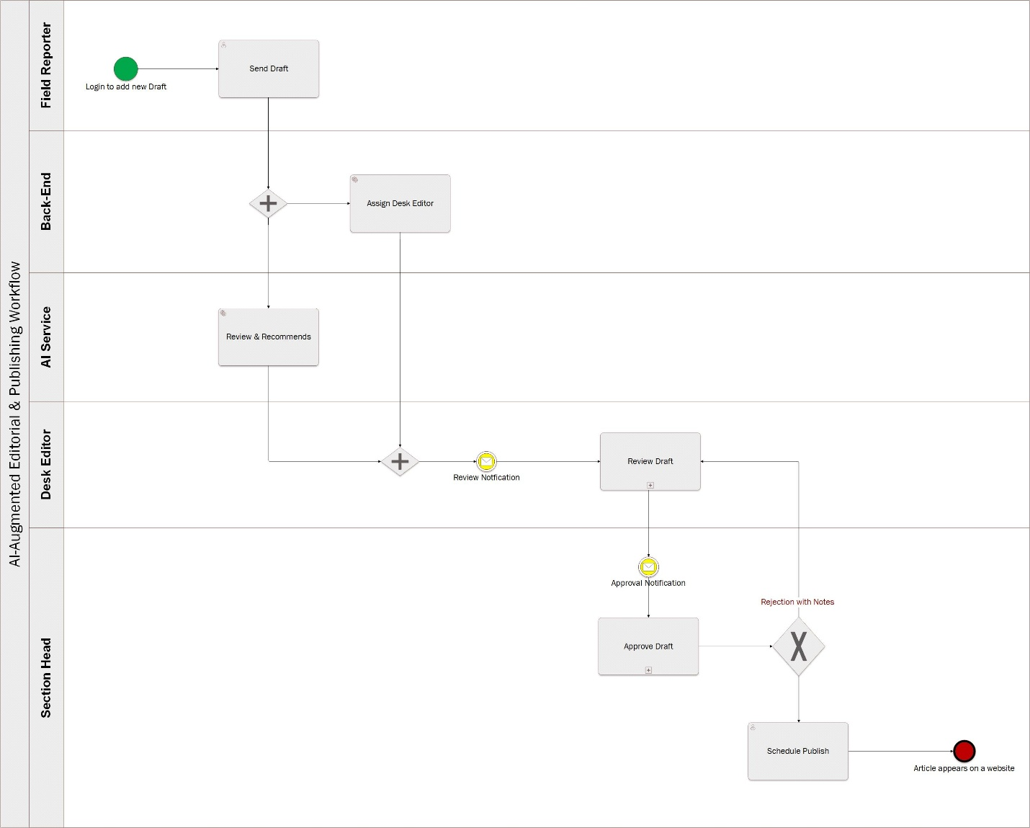

Part 7: Financial Feasibility Study & Investment Appraisal

Estimated 3-Year Total Cost of Ownership (TCO)
The cost structure follows a PaaS-first deployment: one-time engineering and fine-tuning investment (CapEx in Year 1) plus recurring managed cloud operating costs (OpEx in Years 1 to 3).
Cost Category | Expense Classification | Year 1 | Year 2 | Year 3 | 3-Year Total
Custom Platform Engineering & CMS Integration | CapEx (One-Time) | $18,000 | $0 | $0 | $18,000
Open-Source LLM Fine-Tuning & RAG Pipeline Setup | CapEx (One-Time) | $12,000 | $0 | $0 | $12,000
Managed PaaS App & Database Hosting | OpEx (Recurring) | $3,600 | $4,000 | $4,400 | $12,000
Serverless GPU Model Inference (PaaS Endpoints) | OpEx (Recurring) | $4,800 | $5,500 | $6,200 | $16,500
Managed Vector Database & Document Storage | OpEx (Recurring) | $1,800 | $2,100 | $2,400 | $6,300
Staff Training, Governance & Change Management | CapEx / OpEx | $5,000 | $1,500 | $1,500 | $8,000
System Maintenance, Model Drift Retuning & SLA Support | OpEx (Recurring) | $2,800 | $4,900 | $5,500 | $13,200
Total Annual Investment (Cash Outflows) | n/a | $48,000 | $18,000 | $20,000 | $86,000

Tangible Financial Benefits & Revenue Impact
- Financial returns come from two drivers:
Revenue / Cost Savings Driver | Year 1 | Year 2 | Year 3 | 3-Year Total
Editorial Labor Efficiency & Overtime Reductions | $26,000 | $42,000 | $48,000 | $116,000
SEO Organic Traffic Growth & Programmatic Ad Revenue | $14,000 | $31,000 | $44,000 | $89,000
Total Annual Realized Benefits (Cash Inflows) | $40,000 | $73,000 | $92,000 | $205,000

Investment Metrics
- TCO (Total Cost of Ownership)
- Year 1 (CapEx + OpEx): 48,000
- Year 2 (OpEx): 18,000
- Year 3 (OpEx): 20,000
- Total (3-Year TCO): 48,000 + 18,000 + 20,000 = 86,000
- Net Cash Flow
- Net Cash Flow (Year 1): 40,000 - 48,000 = -8,000
- Net Cash Flow (Year 2): 73,000 - 18,000 = +55,000
- Net Cash Flow (Year 3): 92,000 - 20,000 = +72,000
- Cumulative 3-Year Net Benefit: 205,000 - 86,000 = +119,000
- Return on Investment (ROI):
- ROI = (Cumulative Net Benefit / Total 3-Year TCO) * 100
- ROI = (119,000 / 86,000) * 100 = 138.4%
- Payback Period (Break-Even):
- Fraction of Year 2 = Unrecovered Cost at End of Year 1 / Net Cash Flow in Year 2
- Fraction of Year 2 = 8,000 / 55,000 = 0.145 of the year
- Payback Period Fraction in Months = 0.145 * 12 months = 1.745
- Payback Period = 1.745 + 12 months = 13.75 Months (Year 2, Q1)

Part 8: Phased Implementation Roadmap & Rollout Strategy

Phase | Duration | Primary Focus Area | Key Deliverables & Milestones
Phase 1: Foundation & Data Preparation | Months 1 to 2 | Cloud Infrastructure, Historical Data & Base Model | • Provision PaaS cloud environments, container registries, and networking  • Clean and structure the historical news archive.  • Select and benchmark the open-source foundation model, then start vector DB indexing.
Phase 2: Model Fine-Tuning & Core Engineering | Months 3 to 4 | Domain Adaptation & Editorial Workspace Development | • Fine-tune the open-source LLM on newsroom style guidelines and SEO taxonomies  • Build the rich text editor interface with the contextual AI recommendation side panel  • Build and integrate the enterprise RAG retrieval pipeline.
Phase 3: Integration, Pilot Testing & Sandboxing | Months 5 to 6 | CMS Connectivity & Departmental Pilot Run | • Connect the orchestration engine to the production Headless CMS via secured APIs.  • Launch a single-section pilot deployment (e.g., Sports or Tech Desk).  • Tune the hallucination guardrails and measure single-click approval response times.
Phase 4: Full Deployment & Workforce Enablement | Months 7 to 9 | Enterprise Rollout, Training & Governance | • Execute full platform cutover across all editorial desks and field reporters  • Conduct role-specific Human-in-the-Loop training sessions for all 4 system actors.  • Implement automated drift detection, cloud FinOps cost tracking, and operational SLA reporting.

Part 9: Risk Management, Hallucination Governance, and Ethical AI Framework

Risk Domain | Specific Risk Description | Risk Severity | Technical & Operational Mitigation Strategy
AI Hallucination & Fact Distortion | The model produces unverified claims, fabricated quotes, or wrong dates, which exposes Youm7 to reputational harm and legal liability. | Critical | • Ground every RAG response in primary reporter notes and the verified news archive.  • Enforce mandatory Human-in-the-Loop verification; no AI suggestion reaches production without explicit editorial sign-off.
Editorial Bias & Policy Drift | Output drifts from institutional neutrality, varies in tone of voice, or breaks the newsroom style guide. | Medium | • Execute targeted Supervised Fine-Tuning (SFT) using historical stylebook corpora.  • Conduct scheduled quarterly prompt and model weight recalibrations.
Data Privacy & Exclusive Leakage | Embargoed investigative drafts, proprietary news leads, or the identities of reporters' sources reach outside parties. | High | • Enforce tenant-isolated Private Cloud PaaS boundaries with end-to-end encryption (TLS 1.3, AES-256 at rest).  • Enforce a strict zero-retention data policy preventing third-party model ingestion.
Workforce Resistance & Low Adoption | Editors push back because they fear losing their desk, losing control of the copy, or because they distrust automation. | High | • Present the platform as an augmented workspace that removes repetitive proofreading and metadata tagging, not as a replacement for editors.  • Run hands-on training for each role, plus change management workshops.

Part 10: Table: Strategic & Operational KPI Dashboard Matrix

Key Performance Indicator (KPI) | Baseline (As-Is) | Target Metric (To-Be Post-Launch) | Measurement Frequency & Tracking Source
Time-to-Publish (TTP) for Breaking News | 35 to 45 minutes | ≤ 10 to 12 minutes (65%+ reduction) | Real-time CMS Timestamps & Telemetry
Average Editorial Desk Review Time per Article | 20 to 25 minutes | ≤ 5 to 7 minutes | Workflow Orchestration Event Logs
Linguistic & Factual Accuracy Rate | 88% to 90% | ≥ 98.5% | Pre-publication QA Audits & Error Logs
On-Page SEO Compliance Score | 60% to 65% | ≥ 95% | Automated SEO Validation Engine
AI Recommendation Acceptance Rate | N/A (New) | ≥ 85% | Clickstream Telemetry (Accept vs. Reject Actions)
Organic Search & Google News Referral Growth | Baseline Index | +35% to +45% YoY | Google Search Console & Web Analytics
Cumulative Editorial Labor Cost Savings | $0 | $116,000 / 3 Years | Quarterly Financial Controller Audits
AI Inference Latency (Serverless PaaS GPU) | N/A | ≤ 1.5 Seconds | Cloud APM / PaaS Gateway Telemetry
Editorial Staff Adoption & Satisfaction Rate | Low (Skepticism) | ≥ 90% Adoption within 6 Months | Quarterly Internal UX & CSAT Audits

